Google “Ernie”

It will take you to Embry-Riddle Login

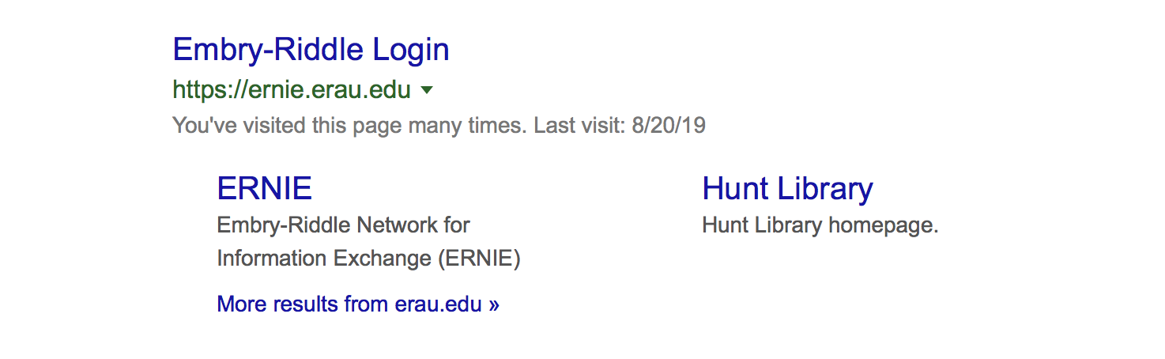
LOGIN

marta114

myname1234567

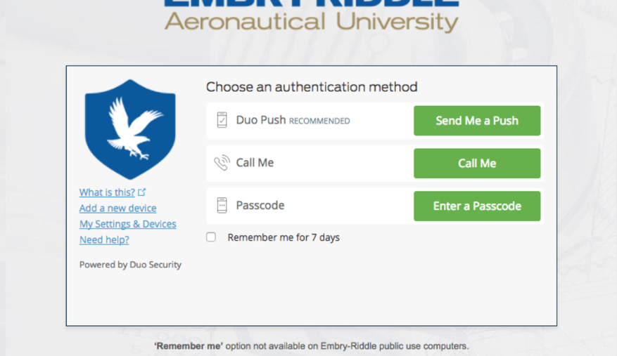

THEN: Press “Call Me”

It will call my phone, and I will let you in.

Where to Find Assignments/Quiz: This is how to navigate to the (2) Assignments and (1) Quiz.

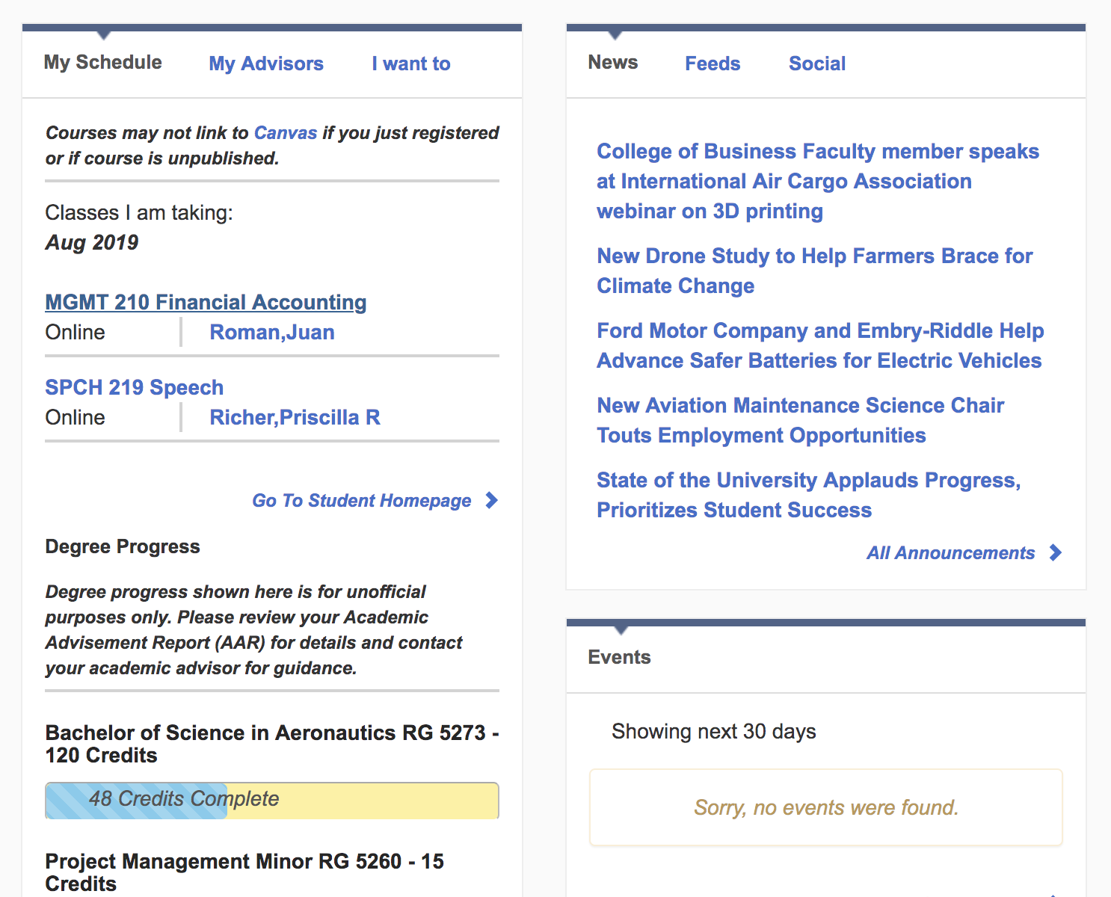

Chose MGMT 210 Financial Accounting
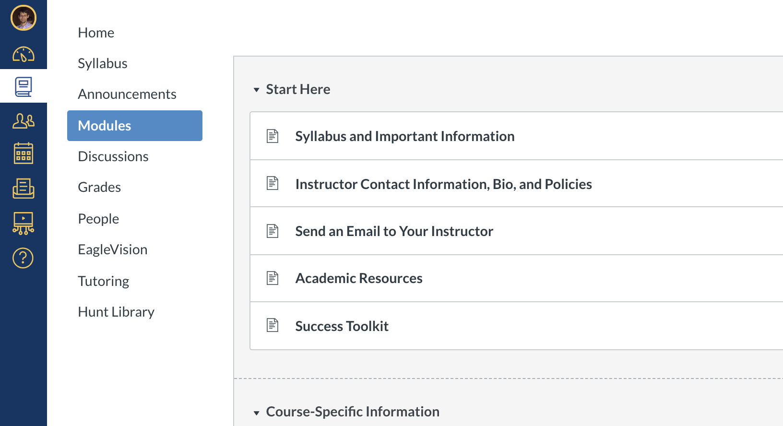

Chose Modules

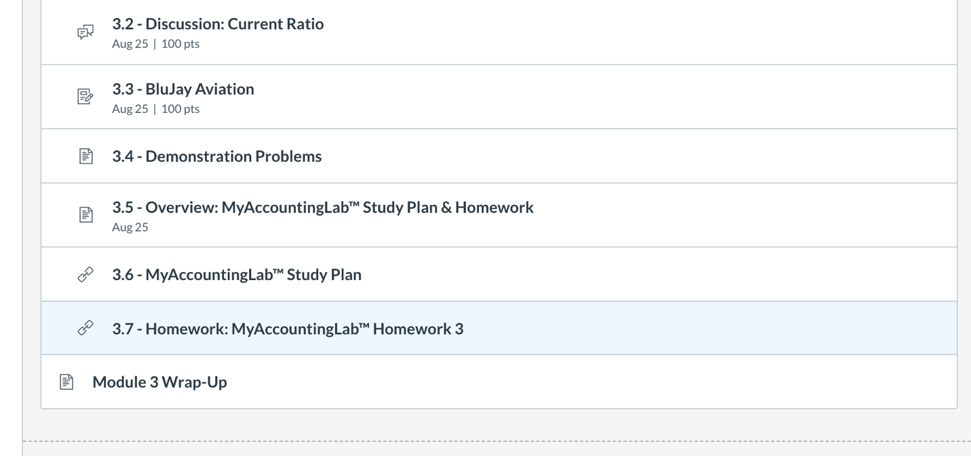

Chose 3.7 Homework: MyAccoutingLab. Homework 3

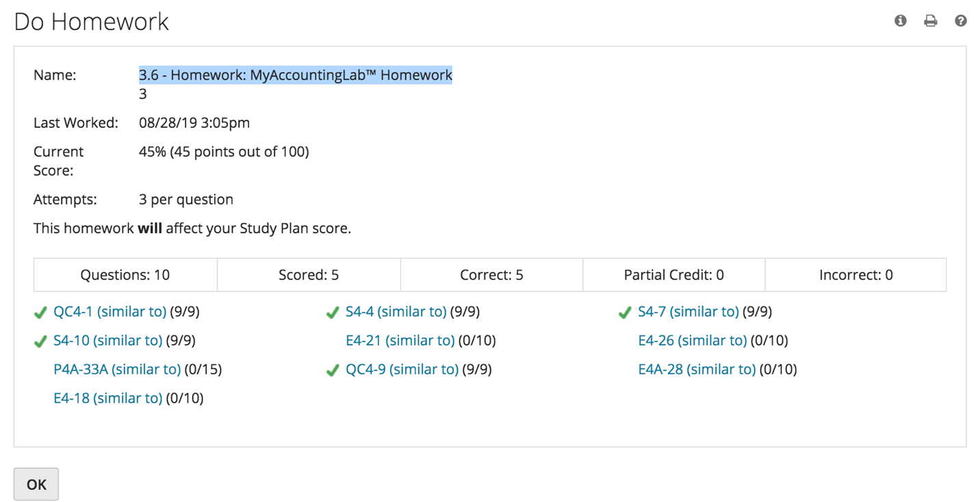

Once you in, notice it says 3.6, instead of 3.7 - Thanks ok. This is it.

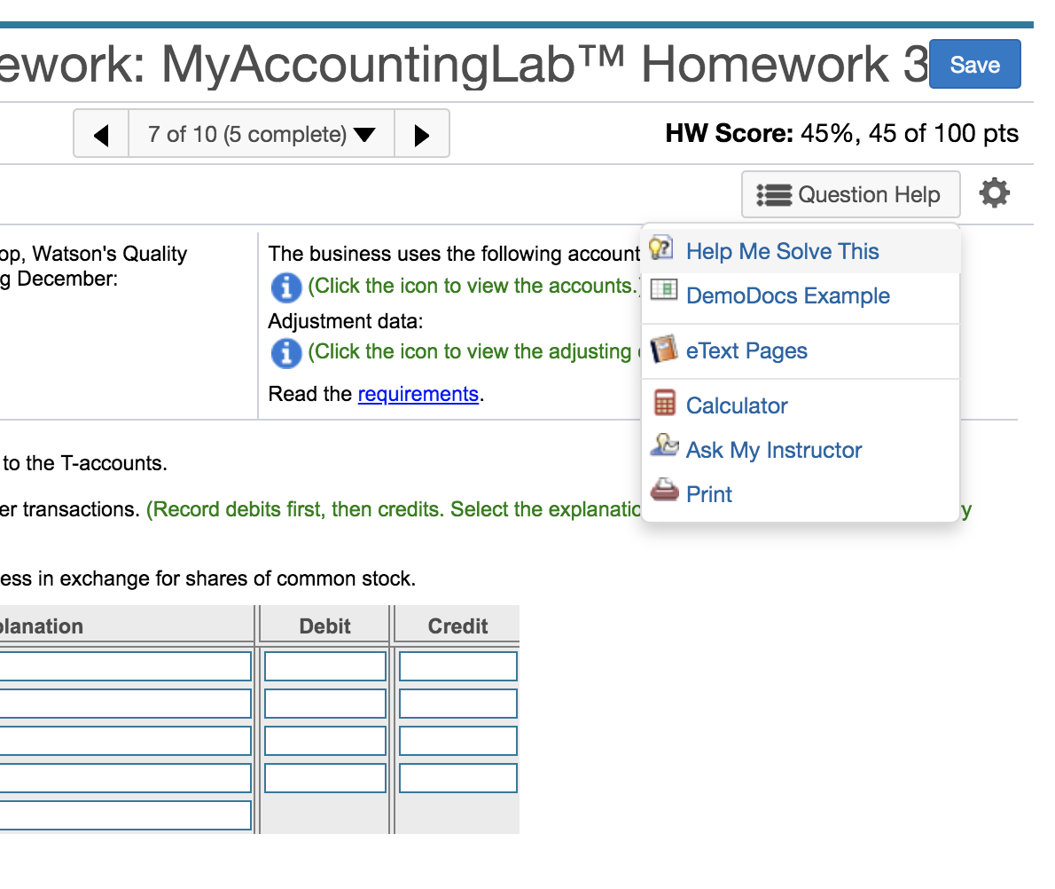

For HW (3) and (4), You can get extra help by clicking: Question Help, then Help Me Solve This.

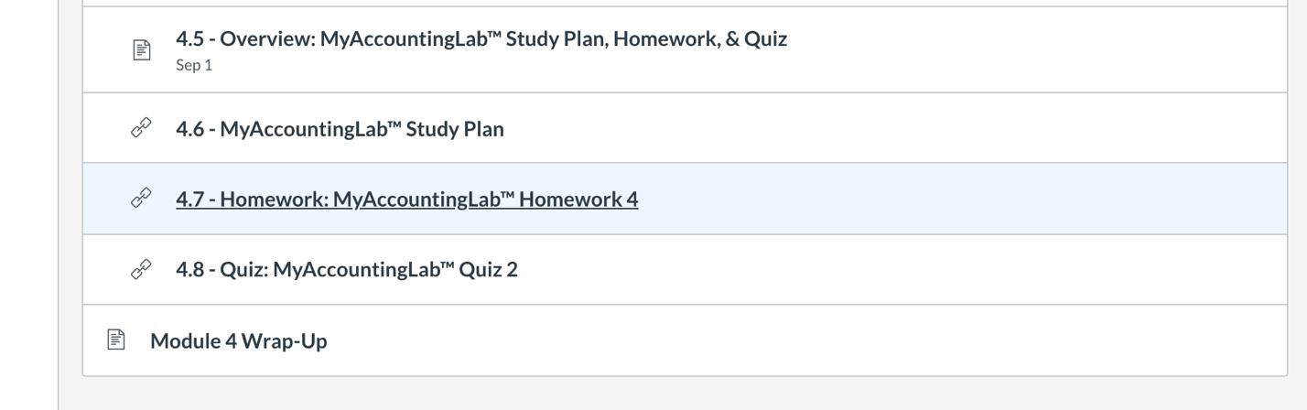

Next: For HW 4 - Chose 4.7 Homework: MyAccountingLab Homework 4

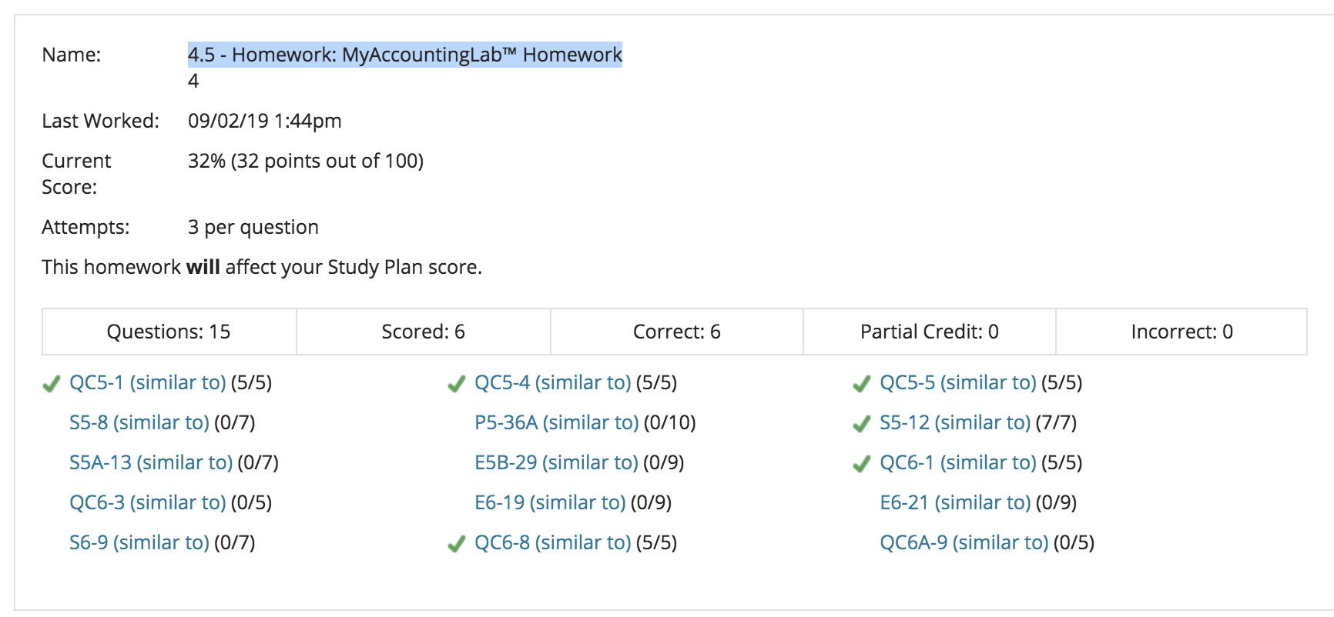

Again, notice it says 4.5, instead of 4.7 - Thanks ok. This is it.

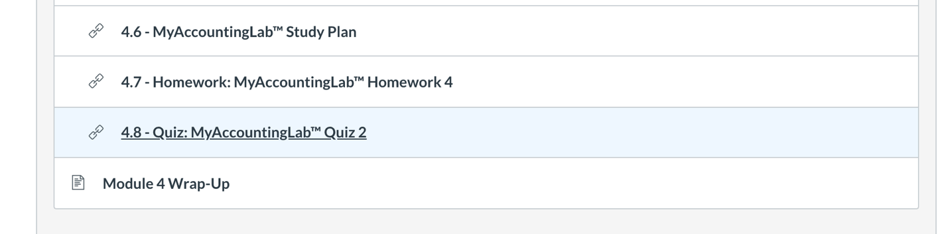

When you ready for Quiz: Chose 4.8 Quiz: MyAccountingLab Quiz 2 *(Really 4.6 Quiz 2)

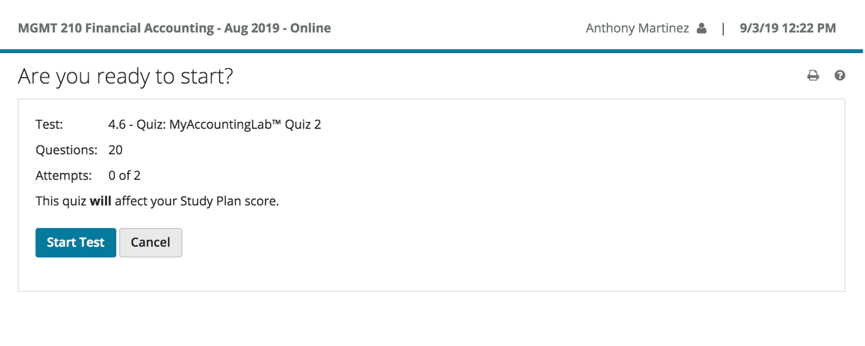
Remember if you have an account with Chegg.com. or CourseHero.com, it helps with some questions.

You have 2 attempts: Good luck, and Thanks a lot!!

